ASSIGNMENT 3

AIM 1:- Implement program of spatial resolution.

Code:-

I='lena.tif';

I=imread(I);

I=imresize(I,[512 512]);

num=512;

for i=1:4

a1 = i;

i1 = 1:a1:512;

I1 = I(i1,i1);

figure,imshow(I1);title(strcat(num2str(num),'*',num2str(num),'image'));

num=num/2;

end

Output:-

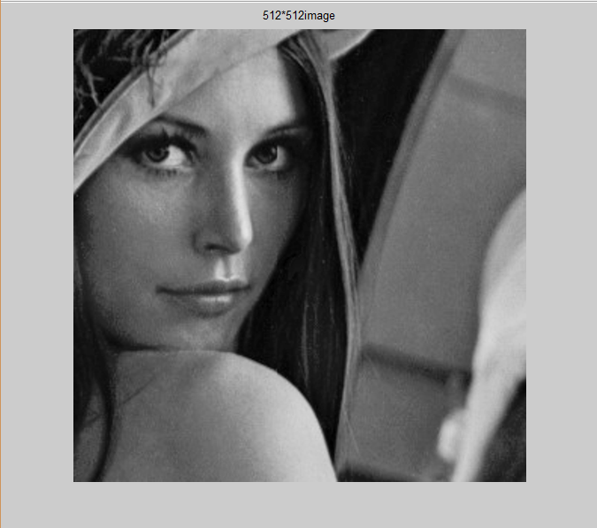

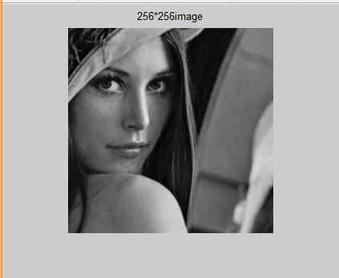

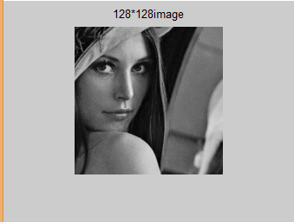

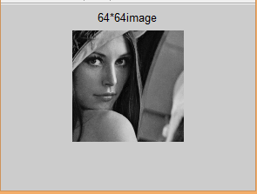

AIM 2:- Implement Program of Intensity resolution.

Code:-

I=uigetfile('*.*','Select the Image');

I=imread(I);

[r c] = size(I);

a=[1 3 7 15 31 63 127 255];

for i=1:8

num=i

L1 =a(i) ; %total number of levels

y1 = uint8(255/L1); %number of gray shades per level

x1 = 0:y1:255; %gray levels in output image

I1 = zeros(r,c);

for i = 1:1:r

for j = 1:1:c

k = uint8(I(i,j)/y1);

k = k+1;

if (k > L1+1)

k = k-1;

end

I1(i,j) = x1(k);

end

end

subplot(2,4,num)

imshow(uint8(I1));title([num2str(num),' bit image']);

end

Output:-

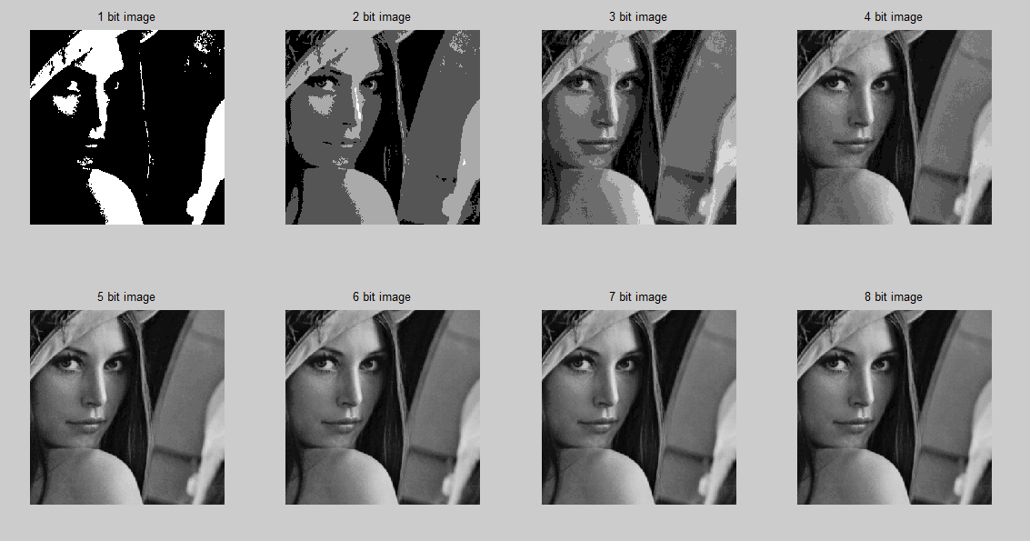

AIM 3:-How to Read/write multiple images from a folder. Explain with Matlab program.

Code:-

clc;

for i=1:6 %suppose there are 10 image

file_name=dir(strcat('D:\MAT-DIP-LAB-TVR\Assignment3\*.jpg')); % the path tht u hv imges

im=imread(file_name(i).name);

subplot(2,3,i)

imshow(im);

imwrite(im,strcat('D:\MAT-DIP-LAB-TVR\Assignment3\Emptybox\',file_name(i).name))

end

Output:-



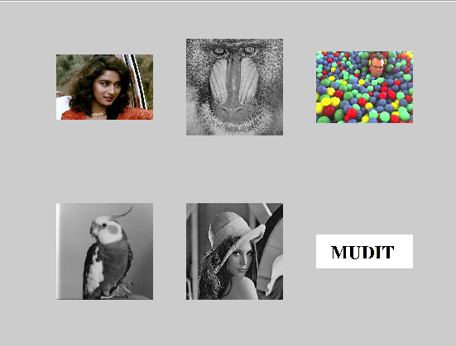



AIM 4:- Implement program to find connected components of an images. Display all connected components. (Minimum 10 images are required)

Code:-

clc;

close all;

clear all;

I = imread('mudit.jpg');

I = rgb2gray(I);

figure,imshow(I);

I = imcomplement(I);

I=I>128;

[a, b] = bwlabel(I,8);

[c,d] = size(I);

I1 = zeros(c,d);

I2 = zeros(c,d);

I3 = zeros(c,d);

I4 = zeros(c,d);

I5 = zeros(c,d);

%for g = 1:b

for e = 1:c

for f = 1:d

if a(e,f) == 1

I1(e,f) = I(e,f);

elseif a(e,f) == 2

I2(e,f) = I(e,f);

elseif a(e,f) == 3

I3(e,f) = I(e,f);

elseif a(e,f) == 4

I4(e,f) = I(e,f);

elseif a(e,f) == 5

I5(e,f) = I(e,f);

end

end

end

I1=imcomplement(I1);

I2=imcomplement(I2);

I3=imcomplement(I3);

I4=imcomplement(I4);

I5=imcomplement(I5);

imwrite(I1,'m.tif');

imwrite(I2,'u.tif');

imwrite(I3,'d.tif');

imwrite(I4,'i.tif');

imwrite(I5,'t.tif');

figure,imshow(I1);

figure,imshow(I2);

figure,imshow(I3);

figure,imshow(I4);

figure,imshow(I5);

Output:-











